Adding thread group to the test plan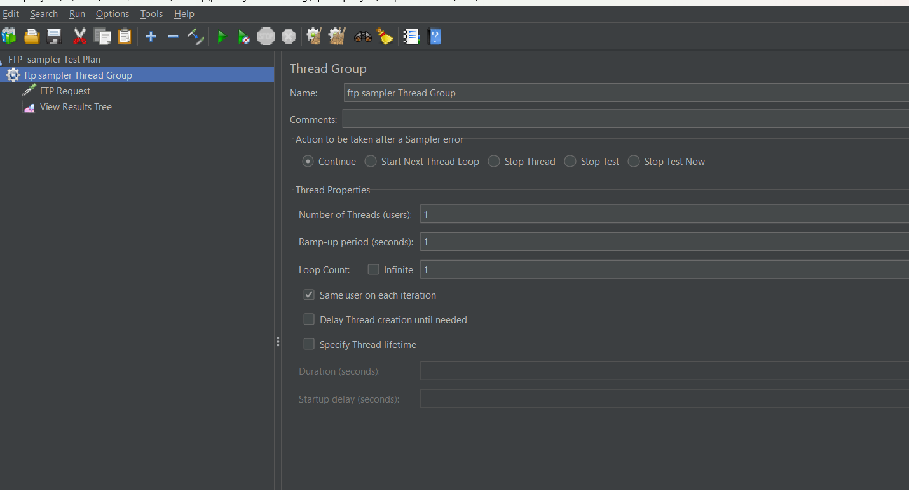

Adding ftp request to the thread group

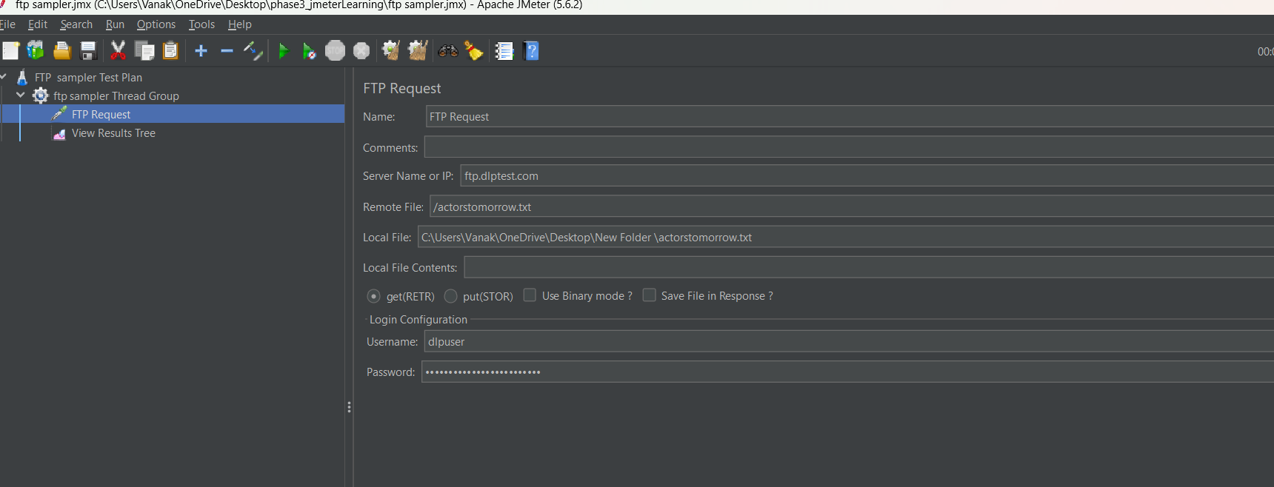

Click on run button

